DESIGN AND ACCESS STATEMENT
Accompanying application for Alterations to Flat 1F2, 19 Gayfield Square, Edinburgh EH1 3NX

BACKGROUND
Flat 1F2, 19 Gayfield Square is part of a B-listed development, situated at the edge of the Edinburgh New Town Conservation Area. The Edinburgh New Town Conservation Area Character Appraisal describes the area as follows:-

The Conservation Area is characterised by Georgian and early Victorian rectilinear development of grand formal streets lined by fine terraced building expressing neo-classical order, regularity, symmetry, rigid geometry, and a hierarchical arrangement of buildings and spaces. They create a regular pattern of stately streets, squares and crescents, interspersed by formal gardens, and containing a series of major classical buildings by architects of the stature of Robert Adam (Edinburgh New Town Conservation Character Appraisal, p.20)

The Area around Gayfield Square is mentioned specifically:
The Gayfield Estate, owned by James Jolie, lay beyond the eastern boundary of the Northern New Town between East London Street and Leith Walk, the main thorough fare to Leith. Jolie, a solicitor, began feuing part of the area in 1785. From around 1807, Hugh Cairncross, a former assistant of Robert Adam, designed a layout for the Gay field Estate which was less formal than the earlier New Town developments. Gayfield Square, a large rectangle opening onto Leith Walk, contained tenement blocks, villas and a row of smaller houses. Broughton Place was lined with two-storey palace fronted blocks similar to Heriot Row but on a smaller scale. Forth Street and Hart Street, by Robert Burn, on Heriot Trust land, are similar in scale. The western section of Gayfield, between Union Street and Broughton Street, con sists of roughly regular rectilinear streets fronted by late Georgian terraces of tenements. Towards the east, the formal grid of streets is based around the development of Gayfield Square which structures the area and is surrounded by a fringe of less regular development which contains significant pockets of piecemeal redevelopment. Gayfield has a substantial residential population amongst other uses. This variety has been extended by redevelopment and by the conversion of residential property to office use. Shop units occupy the street level accommodation along Leith Walk and Broughton Street and occasional shop uses are present in Union Street and other locations (Edinburgh New Town Conservation Character Appraisal, p.29)

The map extract opposite (Fig.1) was published in 1804, and you can see that while the main area of the New Town has already been established, only one half of Gayfield Square has been developed. The block with number 19 is still shown as wooded. By 1878, (Fig. 2, overleaf) the streets have been laid out and you can see the full shape of the square.

The flat lies within a stone-built terrace of four storeys with a basement. The listing LB28806 is a group listing and describes the block as follows:-
Hugh Cairncross, 1808. Classical terraced double tenement block with symmetrical 4-storey and basement, 7- bay elevation to Gayfield Square (6-bay elevation to rear). Droved ashlar (coursed rubble with droved margins to basement; coursed rubble with dressed margins to rear). Dividing band between basement and ground floor; dividing band between ground and 1st floor and between 2nd and 3rd floor; eaves cornice; blocking course. Regular fenestration.
SE (PRINCIPAL) ELEVATION: to centre bay, steps and platt overarching basement recess leading to timber-panelled door with 4-light rectangular fanlight; to 2nd and 6th bays, steps and platt overarching basement recess leading to timber-panelled door with half-wheel design glazing to letterbox fanlight.
GLAZING etc: 12-pane glazing in timber sash and case windows. Pitched roof; grey slates; stone skews and skewputts. 1 stack to front pitch to centre; 1 ridge stack to centre; 1 ridge stack to right; all stacks corniced ashlar with droved dressings and circular cans.
RAILINGS: spear-head and urn finialled cast-iron railings set in stone copes edging basement recess; plain railings edging steps and platts.

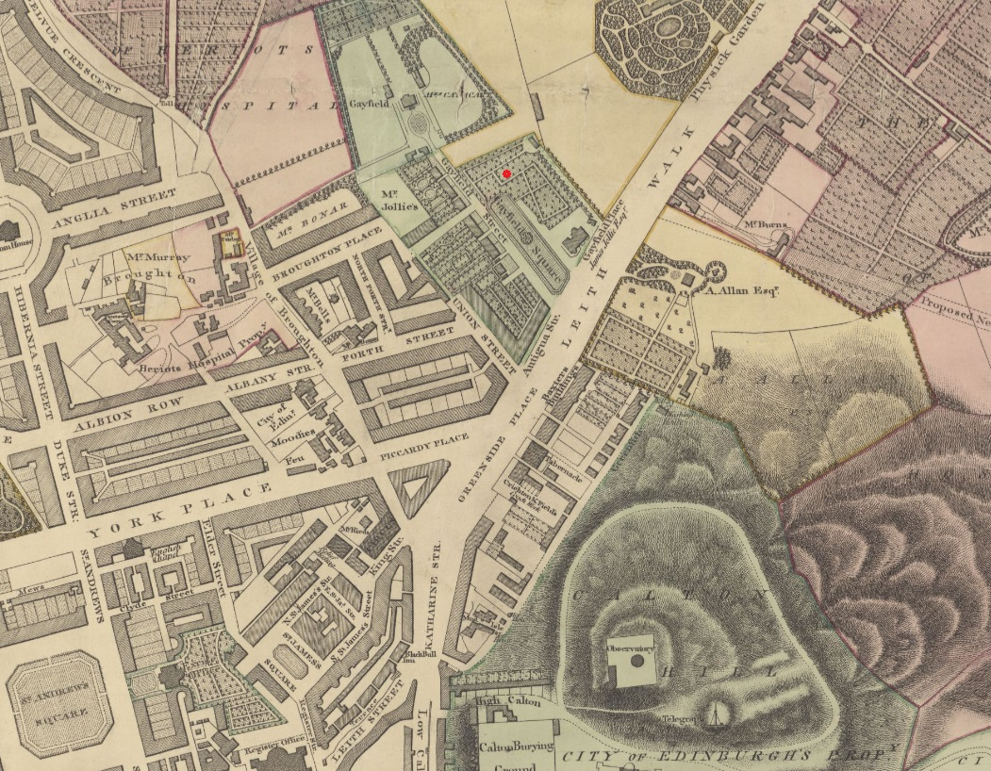
Fig. 1 Map Extract – ‘To the ... Lord Provost, Magistrates and Council ... of Edinburgh this plan of ... Edinburgh and Leith ... is ... inscribed by ... John Ainslie ... / engraved by the surveyor & John Craig his assistant’, Published: [1804]
Reproduced with the permission of the National Library of Scotland https://maps.nls.uk/view/216390258#zoom=3.7&lat=8532&lon=8211&layers=BT
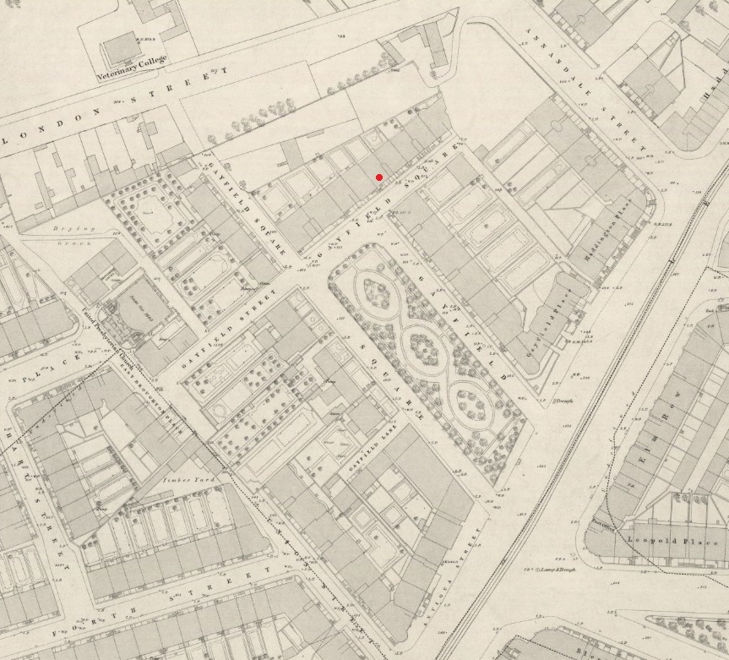
Fig. 2 Map Extract – Edinburgh - Sheet 25. Surveyed: 1877, Published: [1878-81]
Reproduced with the permission of the National Library of Scotland https://maps.nls.uk/view/74415650#zoom=4.5&lat=3995&lon=4762&layers=BT

The listing also contains the following statement of special interest:-
This classically detailed double tenement block is a good example of early 19th century tenement design in Edinburgh. It also has streetscape and historical value as an element of the Gayfield estate development. The relative simplicity of detailing, compared to the adjoining terrace to the left (also by Cairncross; separately listed), is reflective of the building's position on the road running out of the square, which causes it to be largely hidden from view when looking at the square from Leith Walk. It also has significance as one of the few extant buildings designed by Cairncross, formerly a pupil or assistant of Robert Adam, for whom he was clerk of works at several prestigious projects including Culzean Castle and Old College, Edinburgh University.
18-20 Gayfield Square forms part of the Gayfield Estate, so named because it stands on the former grounds of Gayfield House (East London Street; 1763-5, still extant; separately listed Category A). These lands were feued by the solicitor James Jollie from 1785. Building began on either side of the drive to the house, with James Begg's magnificent tenement building to the NE and villas to the SW. These developments began to establish the form Gayfield Square, which forms the heart of the estate. It was part of Jollie's plan from the beginning that this should be so; in January 1783 he advertised that the Gayfield grounds were to be feued for building purposes 'according to a plan.' His advertisement promised prospective feuars 'remarkably pleasant' rustic situation and 'uncommonly beautiful views' in addition to 'the privilege of the area of the square'. Sasines record that '..the area of Gayfield Place [is] to remain an open space for all time coming.'
By the first few years of the 19th century, Jollie had employed Cairncross to prepare plans and elevations for buildings on plots yet to be feued on the NW and NE sides of Gayfield Place, and also possibly for Union Place. There is some evidence to suggest that John Fraser, a builder, bought and built on all the feus on this NW side

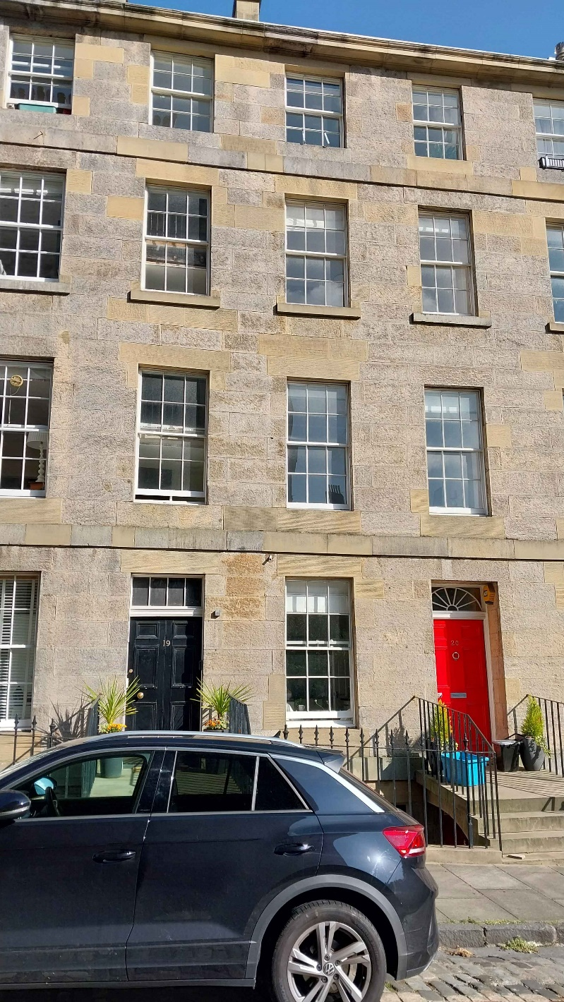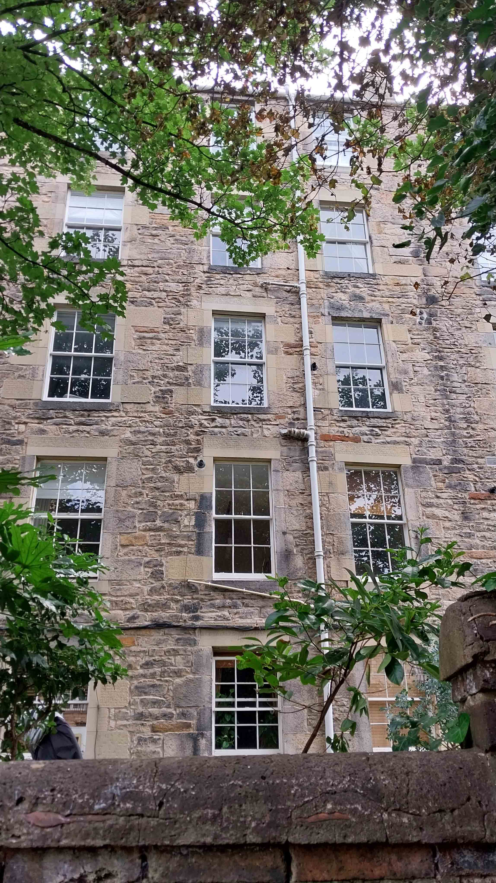

Fig. 3 Front View, Rear View

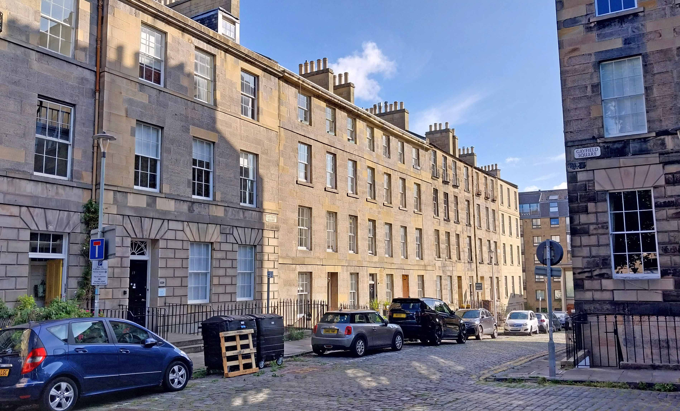
Fig. 3 Front View

The property is Category B Listed as part of the group comprising numbers 18-20. Whilst the front elevation is largely unchanged; internally the flat has undergone multiple changes over the years. This includes an unsympathetic alteration in 1999 to create a property suitable for HMO.

PROPOSALS – WINDOW REFURBISHMENT
Currently there are broken glazing panes to the proposed library. Windows to bedroom 1 do not meet properly at the stiles, and all windows to the flat are extremely draughty. There is some obvious rot to the cills, but the full extent of this will not be obvious until they have been stripped.
All existing windows are to be overhauled, as follows:
· Fully strip back box and sashes, removing paint and sanding.
· Remove existing putty and existing glazing, including broken panes
· Remove existing astragals and check astragals as shown in detail drawing to take a deeper glazing unit.
· Remove rotten wood and replace with new wood and resin.
· Re-glaze with new Fineo vacuum sealed units, total depth of glazed panel 12mm
· Re-use existing astragals.
· Replace all parting and staff beads
· Re-putty
· Fully re-paint, re-rope and re-weight. Paint colour - off white.
· Draught Proof
· Replace all non original ironmongery with new brass ironmongery.
· Repair any damage to sand mastic with new sand mastic – colour to match existing
SUMMARY
The refurbishment of the windows with vacuum glazing will hugely improve the energy performance of the flat, where other energy saving improvements, such as internal wall insulation would not be appropriate due to the existing cornices.

ACCESS STATEMENT
The Scottish Government ‘Planning Circular 3/2013: Development management procedures’ Regulation 13, 3.15 – 3.36 requires a design and access statement to accompany an application for Listed Building Consent. The access statement is a statement setting out how any issues relating to the access to the building for disabled people have been dealt with.
Unfortunately, at the front entrance, the existing situation is that there are 4 steps up to the front entrance, with a further step at the main door. Additionally, as this is a 1st floor flat, there are a further 3 small flights of stairs to access the entrance door to the flat, with no lift access. Once within the flat however, everything is all on the same level. Existing doorways are reasonably generous, and the proposed changes would improve accessibility within the kitchen and bathroom accommodation.
Fernandes Binns Architects January 2026

