-WP1-
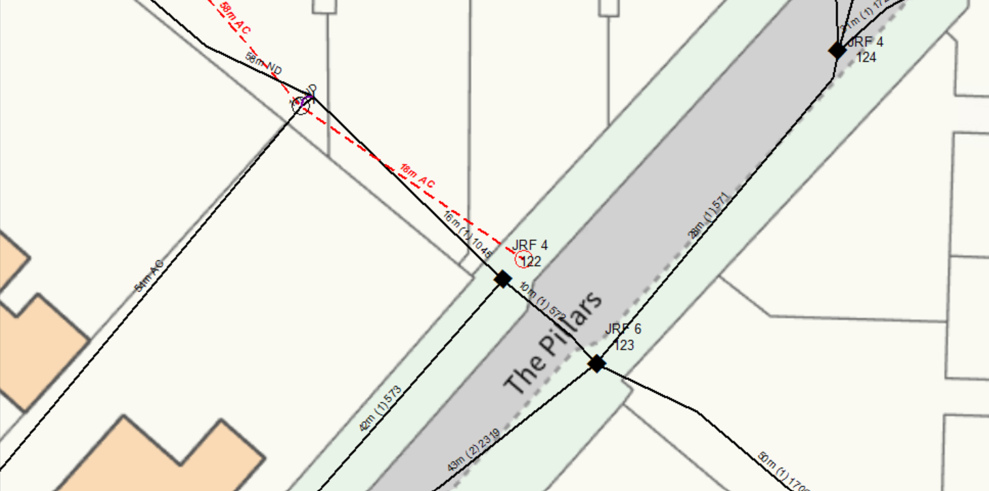
INSTALL NEW 7M LIGHT CARRIER POLE IN S/W AT WP1
WP1:NEW 7M LIGHT POLE
GRID REF: 328920,669134 -436188

