-WP1-
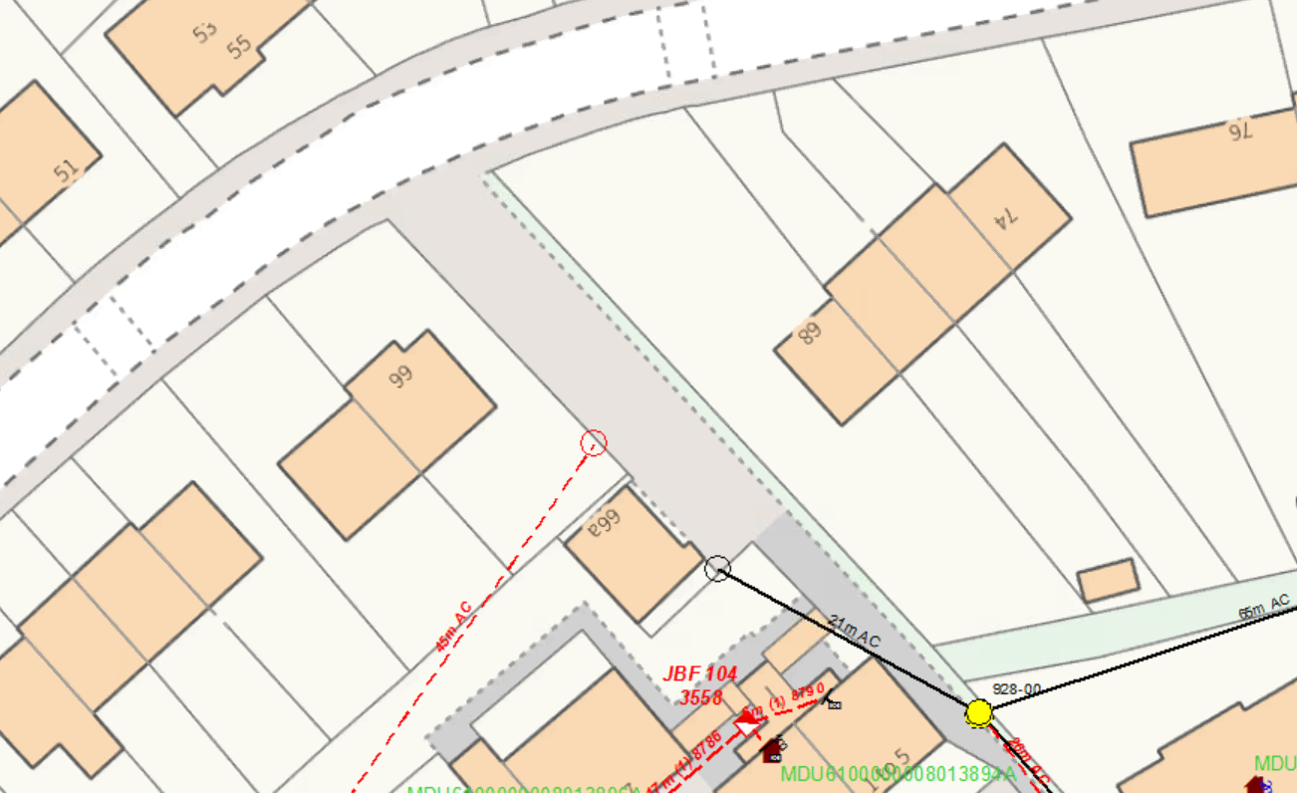
PROVIDE NEW 9M LIGHT CARRIER POLE IN S/W AT WP1.

WP1: 9M LIGHT POLE
GRID REF: 329465,669282

