-WP1-
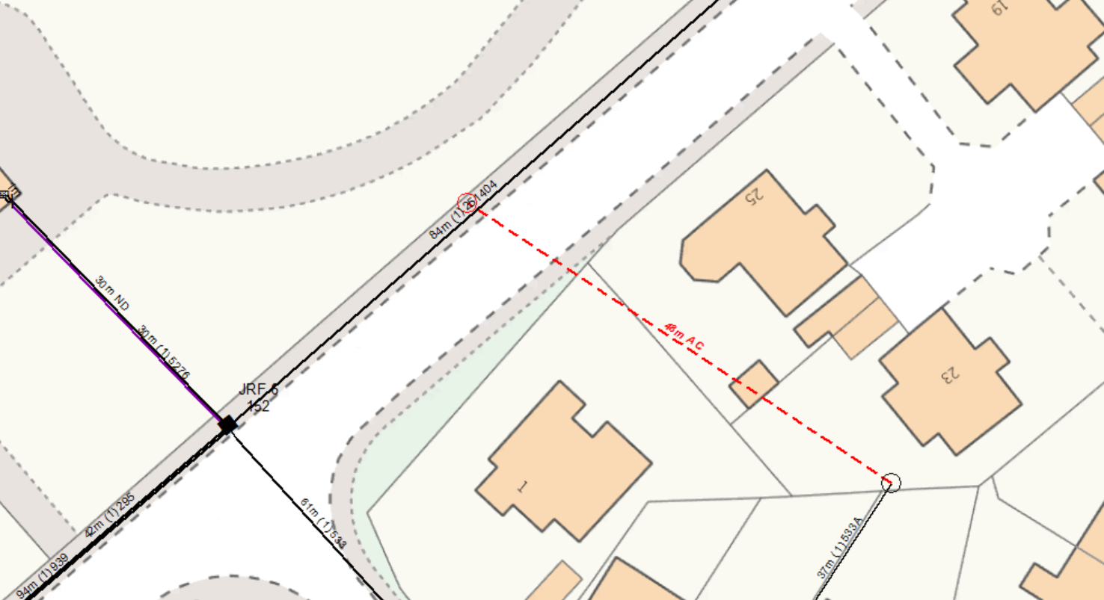
WP1:NEW 11M LIGHT POLE
GRID REF: 315957,666362 436188
INSTALL NEW 11M LIGHT CARRIER POLE IN F/W AT WP1

