-WP1-

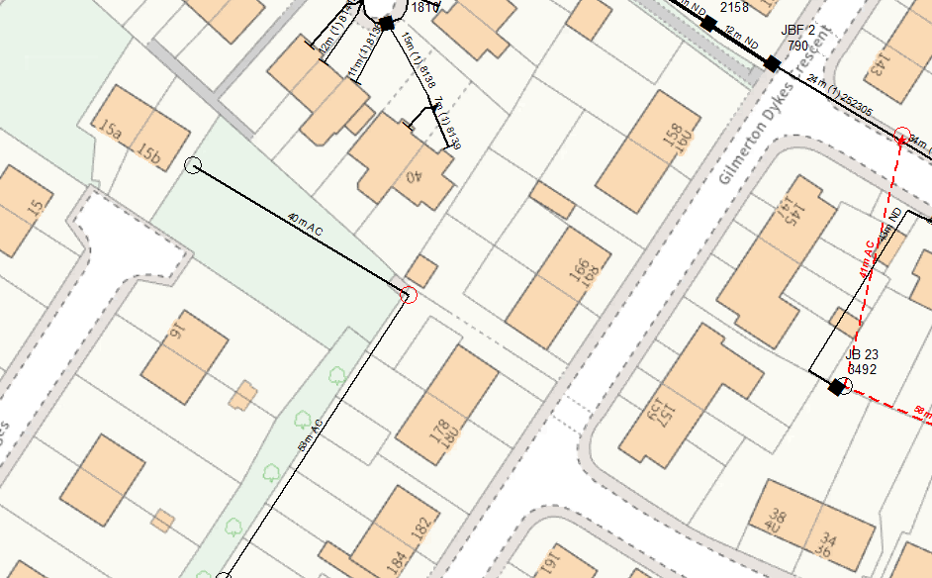
WP1: 8M LIGHT POLE
@GRID: 328252668697
REPLACE BT GENERIC POLE WITH NEW 8M LIGHT POLE IN SOFT FOR NEW CBT AT WP1

