-WP1-/-WP2-
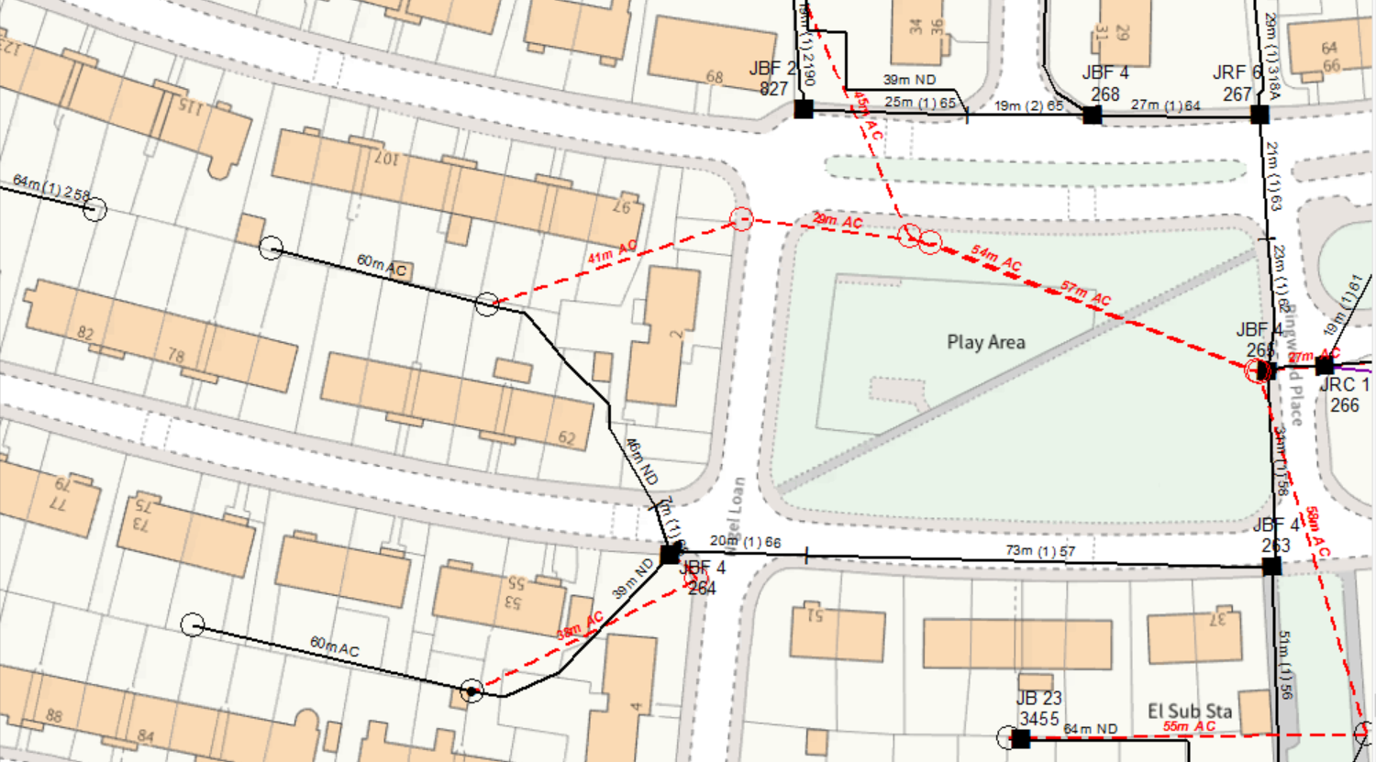
ERECT A NEW 10M LIGHT GALV POLE IN HARD FOR CARRIER POLE AT WP1
WP1: 10M LIGHT GALV POLE @GRID:327596669980
ERECT A NEW 10M LIGHT POLE IN HARD FOR CARRIER POLE AT WP2
WP2: 10M LIGHT POLE @GRID:327589669925

