-WP1-
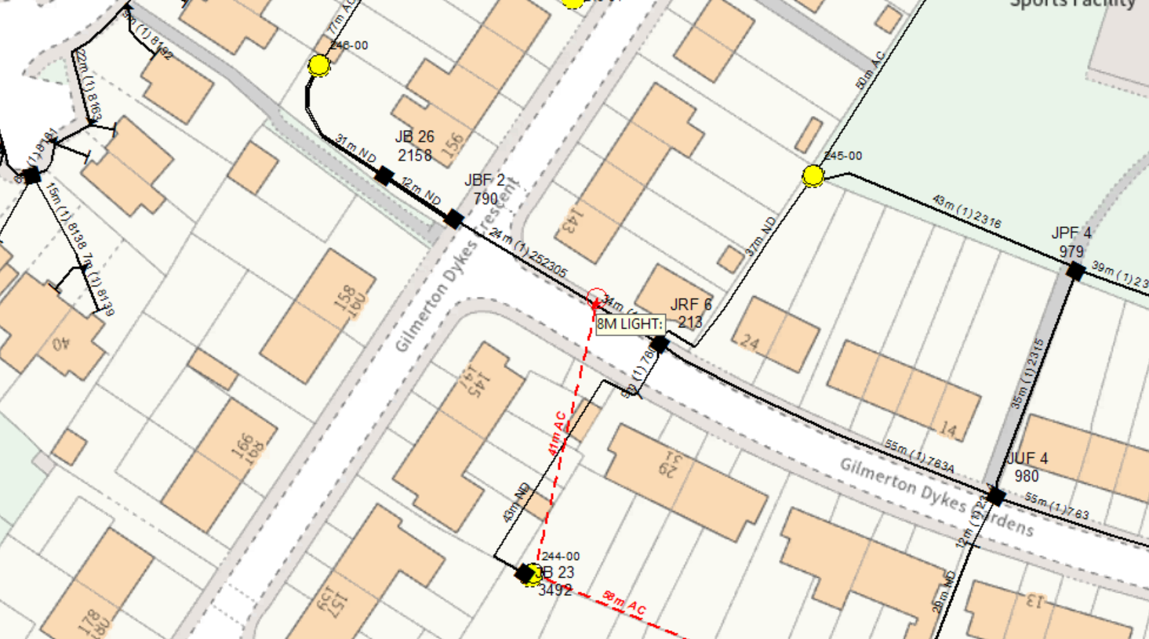
INSTALL NEW 8M LIGHT POLE IN F/W AT WP1

WP1: 8M LIGHT POLE
GRID REF: 328331668723

