-WP1-WP2-
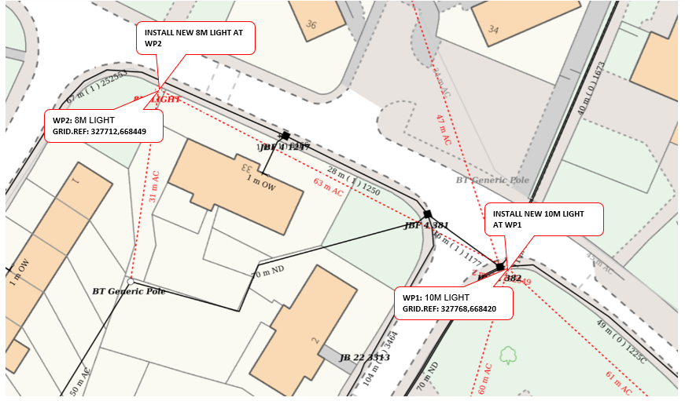
WP1: 10M LIGHT, : FOOTWAY, LIBERTON, EH16 6RN, G/R: 327768,668420
WP2: 8M LIGHT,GRASS VERGE, LIBERTON, EH16 6RW, G/R: 327712,668449

