WP-1,WP-2,WP-3,WP4
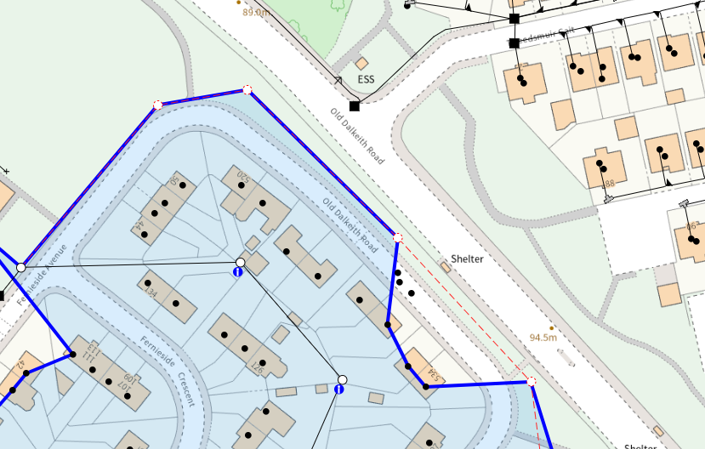
WP4: 8M LIGHT
GRID.REF.: 329637669587
WP3: 10M LIGHT
GRID.REF.: 329675669545
WP2: 9M LIGHT GALV
GRID.REF.: 329568669625
WP1: 8M LIGHT
GRID.REF.: 329594669630

