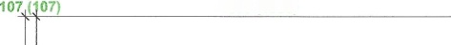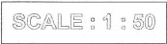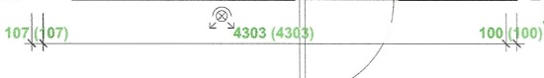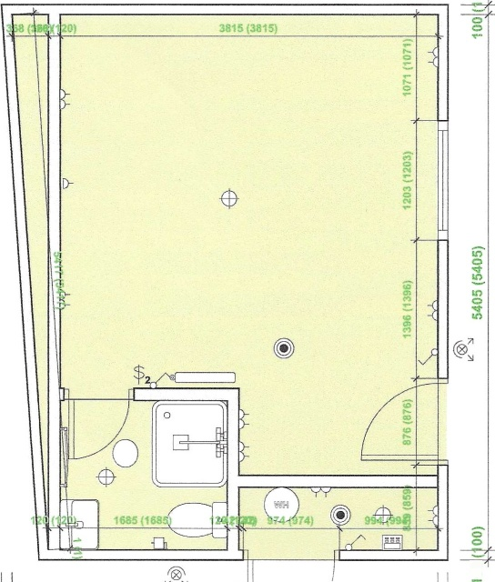
0
a
a
a
a
a
a
a
in
a
q
in
K)
a

K)
'Q
a
\UP
a
a
4303 (4303)
loo.(3oo)
[F

