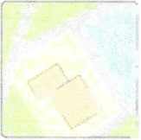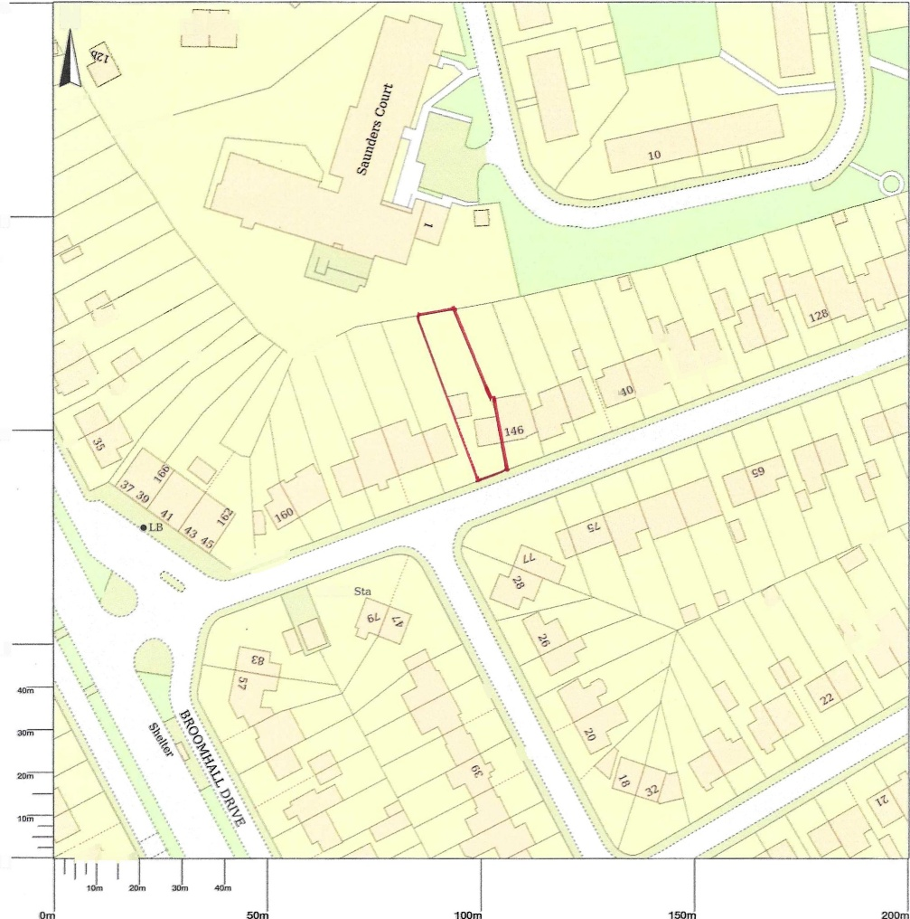
t
.i

UK
- '"\v'/\
148 Broomhall Road, Edinburgh, EH12 7PP
2(Dm
N
ali I

150nr

.V/

dPP +
an O^{n}
+P=•+

iP
II //'
\rJ>.
IDOR

I
El Sub
L/'
50FrT

r,/)~.

/ / / P r / P r
Onr
Scale 1 :1250
© Crown copyright and database rights 2025 OS 100054135. Map area bounded by: 319380,672342 319580,672542. Produced on 07 October 2025 from the OS National Geographic Database. Supplied by UKPlanningMaps.com. Unique plan reference: p4f/uk/1322520/1772967

