Rosebank House, 190-192 Newhaven Road, Edinburgh, EH6 4QB
Design Statement for Proposed Garden Changes

Site and Context

Rosebank House is a two storey Georgian villa built circa 1820 set in its own spacious garden. The house is a well-proportioned symmetrical sandstone building set within rectangular boundary walls. The walls are course rubble and the central door has surrounding columns and an original decorative fanlight so gives a grand entrance to a moderately sized house. The house retains its traditional materials, with all the walls still sandstone, the roof is slate and the sash and case windows wood.

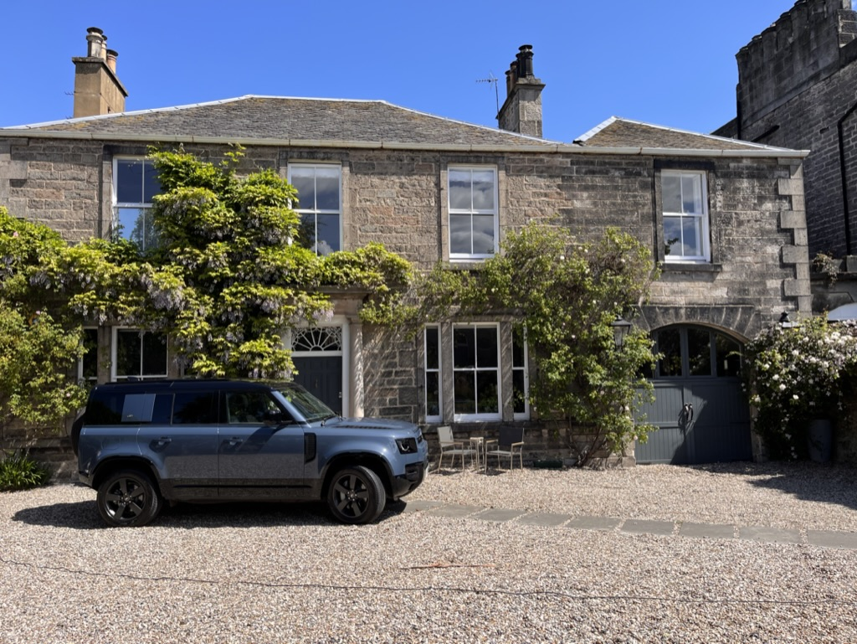

The boundary walls are coped rubble to Newhaven Road and a mix of brick and stone to Dudley Crescent. On this side layers of brick of different clays have been added over time, sometimes intermingled with layers of rubble. The walls range between 2.9m in height on the Dudley Crescent side to 1.8m in height (at the lowest point near the Betula pendula) on the Newhaven Road side. The front has tall gate piers flanking the driveway that have large projecting square stone caps.

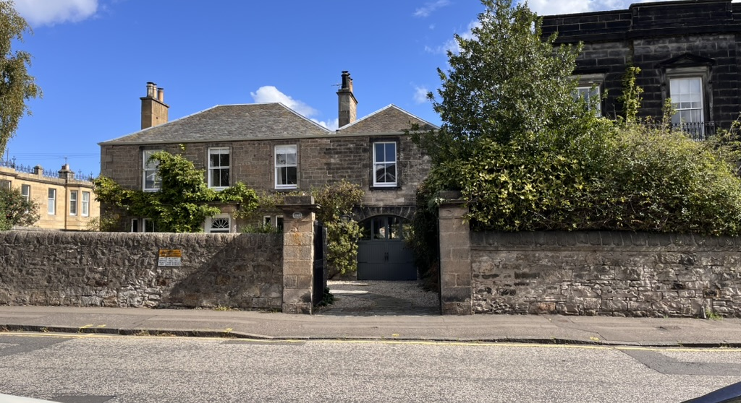
Gate piers with view of stable block now converted to living room
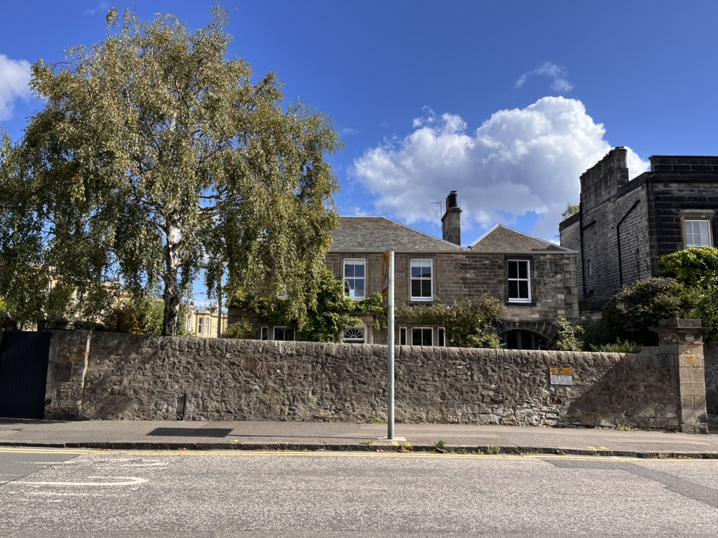
View from Newhaven Road, random rubble wall with stone coping
1.8m at lowest height

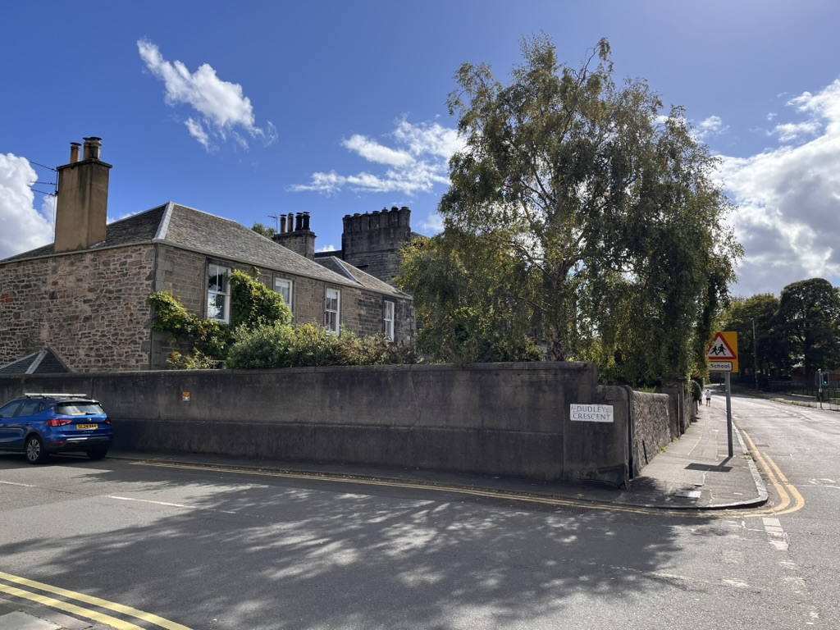
View from Dudley Crescent, random rubble wall, rendered on outside of
property

Rosebank House was originally built as a residence for the Harbour Master of Leith and before the surrounding Dudley Estate was built to the East it would have had views out over the harbour down the hill. There were originally flagpoles in the garden for the Harbour Master to send signals down to the ships in the late Georgian period.

Site Appraisal

The design aims to enhance the garden back to the level of “well landscaped grounds” as stated in the Conservation Area Character Appraisal, something that is currently missing from the property. The following are elements the design wishes to improve on –

Front Garden

1. Front door entrance footing very thin and not a generous welcoming area
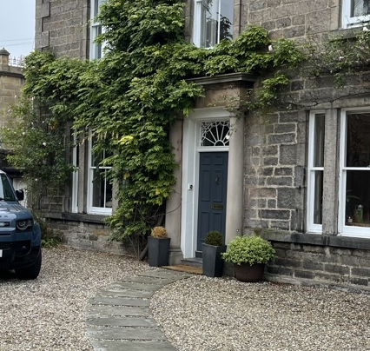

2. Pedestrian walkway of thin slabs in gravel are breaking up due to weight of cars
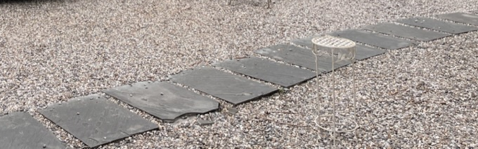

3. No storage space for bikes

4. Very few plants in front garden compared to amount of space

5. The front area has the feeling of being solely a large car park for one car, rather than a garden at all, despite the fact the North corner of the space has the best aspect of the whole property. One of the residents is currently studying Nutrition and would like to have a space to grow vegetables and fruit for the family in a sunny spot
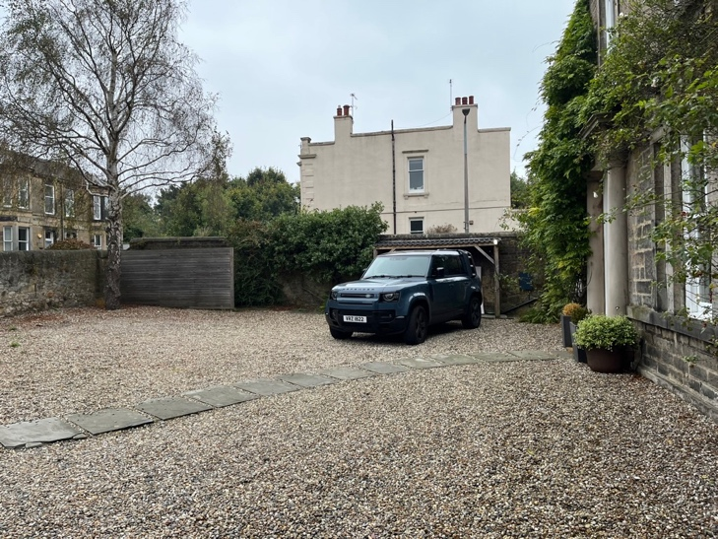

Back Garden

6. Stone paving in back garden does not enhance the stone of the house, it is blue/grey thin slabs and makes the back terrace feel dark and sharp
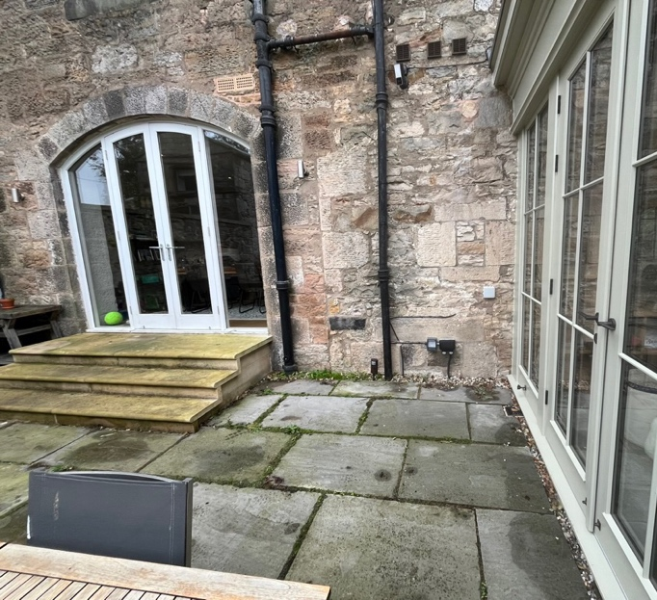

7. Paving in front of sunroom has been added later and terrace edge is not in line. This has left a sharp point that feels dangerous due to slippy wooden steps
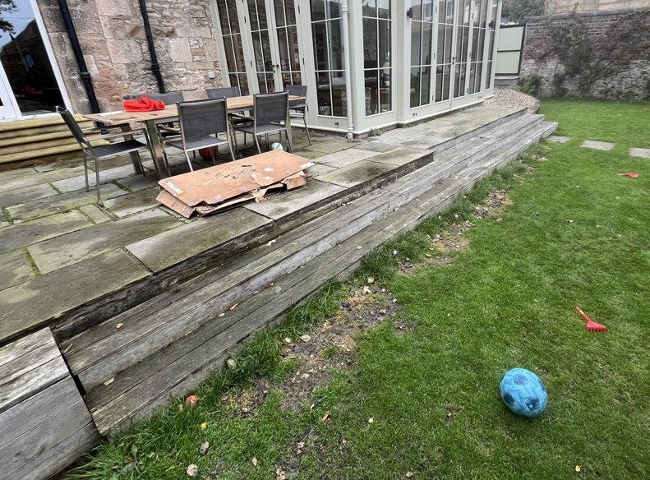
8. Wooden steps are butted against stone on terrace. These are too thin to be comfortable to step down and are slippy in wet weather
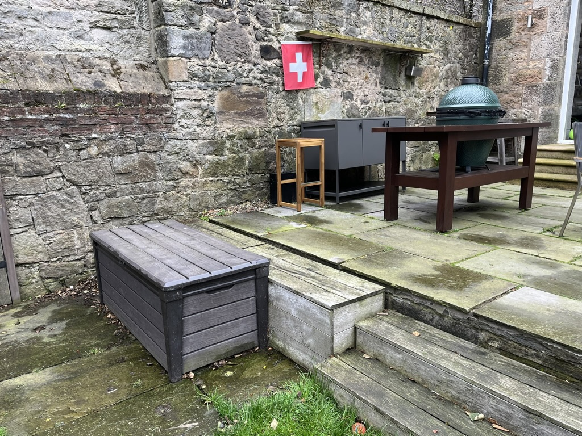

9. The landing area on the sunroom part of the terrace is too thin to have more than one person walking along it, it feels like a corridor in proportion and not somewhere to relax and view the garden
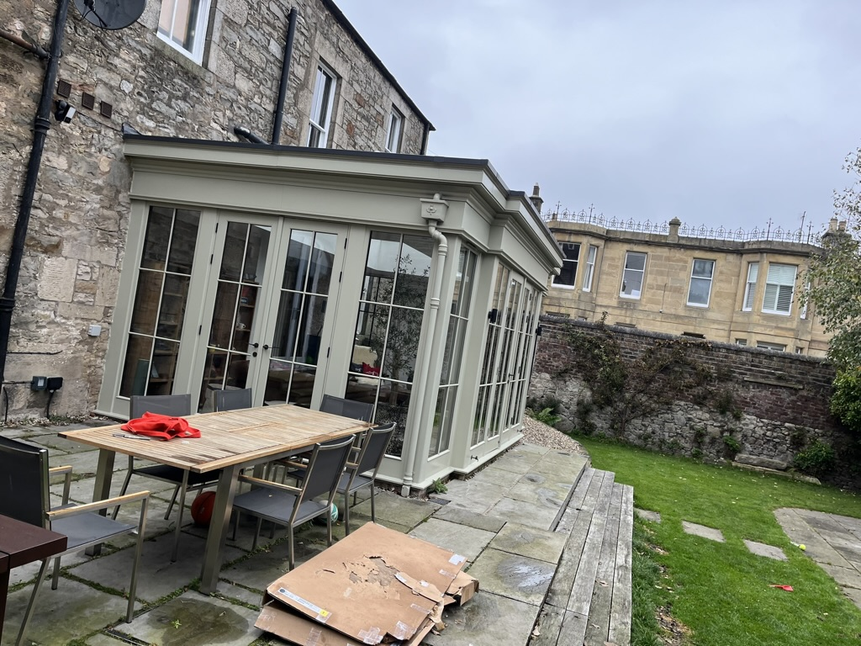

10. The lawn is dominated by a large paved area of same grey/blue paving. The paved area is backed by a white metal screen. These are the same shape as the gable end of the neighbouring house built in brown brick. The shape of the patio and the metal screen draw the eye towards this large shape and makes it the focal point of the garden
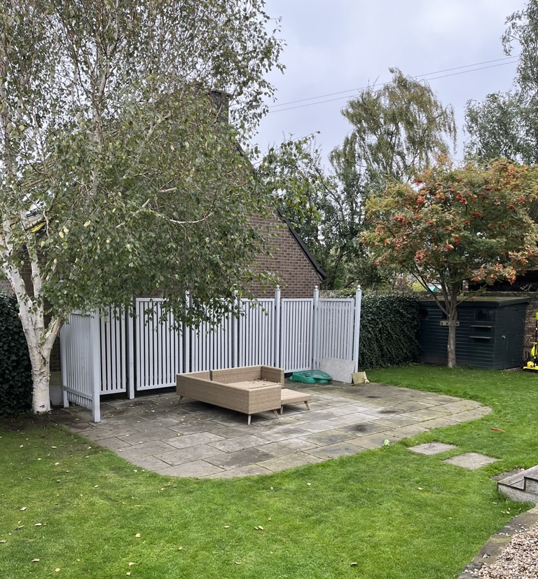
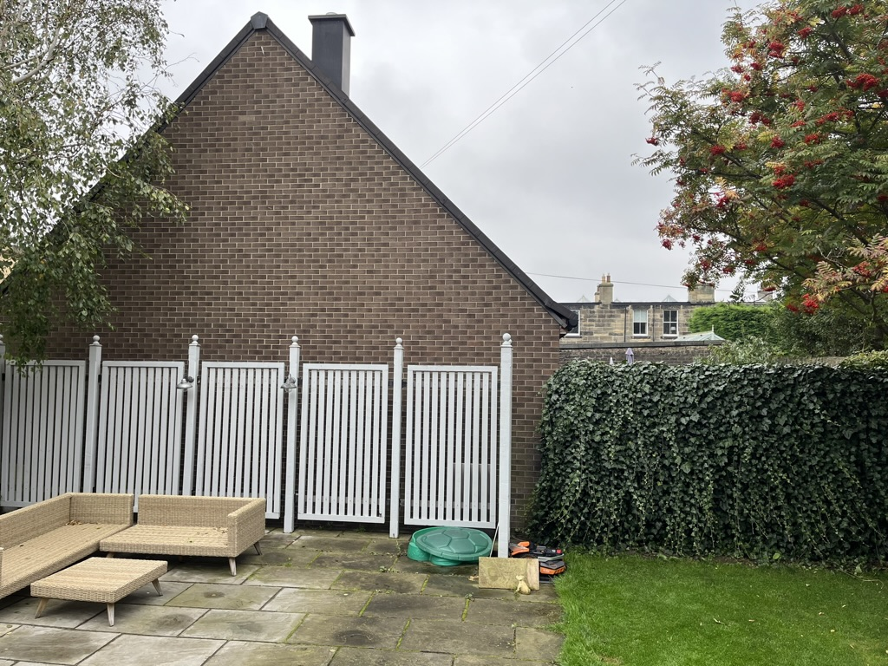

11. Not enough herbaceous plants in back garden, this adds to the fact it feels slightly sterile with little provided for insects and wildlife.

12. The two young children who live in Rosebank House would like to spend more time playing in the garden, climbing, growing things, looking at bugs and playing football.

Design Concept and Solutions

Design Concept
Rosebank House has an impressive level of built heritage status and the design aims to enhance its integral characteristics while making it a more beneficial surrounding garden for the family that currently live there. The house is often viewed from the street by passers-by as an attractive historical dwelling. The design hopes to upgrade the setting of this Listed Building by making a garden that references its material make-up by using the same high quality natural materials.

Design Solutions
1. Front door entrance footing very thin and not a generous welcoming area
The design aims to keep the symmetry of the house in mind but also conveys some of the lack of ostentation and air of restraint in the area, as referred to in the Victoria Park Conservation Area Appraisal (1998). The entrance to the house is currently one thin step, which seems very meagre in comparison with the columns surrounding the front door. The design will extend the hard standing of the entrance area with sandstone paving that is more in keeping with the stone the house is built from. The area closer to the front door will be more formal and symmetrical as an area of paving large enough to welcome a group of people into the house or for luggage or shopping to be put down on. This then extends out in a more informal fashion with gravel in between slabs, as paths pedestrians will be taking towards the house from the gate and the car parking space.

2. Pedestrian walkway of thin slabs in gravel are breaking up due to weight of cars
The design removes these thin slabs and replaces the path with 40mm heavy-duty honeycomb gravel stabiliser, this will not be visible to the eye but is easier to walk on and is a suitable product for heavy duty car parks. The emphasis and layout of the paving and pathways in the front garden are now more weighted towards pedestrians and visitors walking in the gates.
3. No storage space for bikes
The family living in the house would like to use the local cycle paths they live so close to more and have applied to put storage for 4 bikes in the front garden. This will be positioned directly behind the front boundary wall to the road and will not be visible above the wall when looking at the principal elevation of the house. There is currently wooden screening at the entrance to the house, the plan is to add to this and continue the screening around the corner to hide the bike storage shed from view of the house as well.

4. Very few plants in front garden compared to amount of space
The design of the front garden aims to move parking further away from house and make the South-facing sunny areas closer to the house more of a useable garden, with space for growing vegetables and cut flowers. Currently the space is mostly gravel with one flower bed not visible from the road. The design changes this by breaking up the space using low-growing perennial plants and shrubs. The aim is to soften the front of the house and add in more greenery. The driveway to the car parking spaces will be informally demarked by ground-covering evergreen perennials like thyme that can take the occasional car weight if driven over.

5. The front area has the feeling of being solely a large car park for one car, rather than a garden at all, despite the fact the North corner of the space has the best aspect of the whole property. One of the residents is currently studying Nutrition and would like to have a space to grow vegetables and fruit for the family in a sunny spot
The family have one car and the parking space of this will be changed to further away from the house. The car parking space is currently in the best sunspot of the whole garden and makes the car very visible from the house. The EV charger will be moved further along the wall (see Site Plan proposed) and the parking space will be replaced by raised vegetable beds and a cut flower bed along the wall. Raised vegetable beds were chosen to retain a level neatness in the front garden. They will have evergreen low-growing shrubs in front of them so will not be that visible in the winter when there isn’t as much foliage on the veg beds.

6. Stone paving in back garden does not enhance the stone of the house, it is blue/grey thin slabs and makes the back terrace feel dark and sharp
The predominant use of cream and yellow sandstone in the house and the local area will be brought into the garden design with sandstone quarried in Yorkshire replacing some of the current stone paving. The design proposes to use high-quality Yorkstone paving at the front and back of property. The gravel at the front of the property will be kept and added to if needed.

7. Paving in front of sunroom has been added later and terrace edge is not in line. This has left a sharp point that feels dangerous due to slippy wooden steps
The design aims to remove the current paving on the back terrace but keep the current raised structure. This will be extended out slightly so both areas of the terrace visually come out in line with each other.

8. Wooden steps are butted against stone on terrace. These are too thin to be comfortable to step down and are slippy in wet weather
The steps will be the same thick sandstone that is in keeping with the colour of the house. They will have bullnose edges to soften the steps. This will make them less sharp both physically and visually than the current stone, they will be less slippy than the current wooden steps. They will also be longer and less steep in tread than the current steps. There will be improvements in their safety, visuals and ease of use. Steps and paving will be laid to a suitable fall and drain to adjacent pervious surface (lawn).

9. The landing area on the sunroom part of the terrace is too thin to have more than one person walking along it, it feels like a corridor in proportion and not somewhere to relax and view the garden
See number 7.

10. The lawn is dominated by a large paved area of same grey/blue paving. The paved area is backed by a white metal screen. These are the same shape as the gable end of the neighbouring house built in brown brick. The shape of the patio and the metal screen draw the eye towards this large shape and makes it the focal point of the garden
The existing paving is to be removed and replaced with lawn and an area of gravel in the shadier part of the garden to stop bare patches of grass. The white metal screen will be removed and replaced with the same ivy hedge screening that already covers some of the back of the garden boundary. This ivy hedge is 40cm away from the neighbours’ fence and is trimmed with a hedge trimmer once a year to stop any encroachment on the neighbours’ property. The gable end of the next-door house is currently a dominant feature of the garden as this is what the house looks directly towards. This will be screened year-round by planting a multi-stem dwarf evergreen tree in the garden.

11. Not enough herbaceous plants in back garden, this adds to the fact it feels slightly sterile with little provided for insects and wildlife.
The design proposes to put many more flower beds into the back garden, these will be filled with herbaceous perennials that are picked to increase the flowering period of the garden. The hard landscaping such as the terrace will be broken up with flower beds that are dug through to the soil underneath so watering over the summer is less of an issue for plants. Although the proposed terrace and new steps will be slightly larger than the previous terrace, the new terrace will be broken up visually with lots of plants and this will soften its visual impact and decrease the amount of rain run-off the hard standing. The sunroom terrace and the living room terrace are also to be broken up visually by steel planters. The steel planters have no base and stepping stones the same level as the terrace will be made with the same sandstone paving slabs as their surface. There will be leafy foliage growing from these steel planters out of the steps. The steel planters will be galvanised steel that is powder coated in the same pale green the sunroom is painted in. This will fit into the visual backdrop of the building. At the same time the metal planters will keep the level of the stone terrace but extend it out into the garden steps, therefore breaking up the areas of the garden visually and making each area seem slightly more enclosed. This will improve the feeling of the space and make it feel less like a long rectangle with the only visual interest happening around the edges.

12. The two young children who live in Rosebank House would like to spend more time playing in the garden, climbing, growing things, looking at bugs and playing football.
The design aims to bring excitement for children to the space by adding a climbing frame that wraps around part of the Silver Birch in the back garden. This is yet to be commissioned by carpenters but the materials will be natural – wood and rope. The children are 7 and 10 so the climbing frame will fit into the family’s lifestyle for the next few years but will be removed as the family dynamic changes. The aim is to build a wooden structure that weathers to a natural grey, that is not visible from over the boundary wall and impacts the Silver Birch roots as little as possible by having small diameter concrete foundations that minimise impact on any roots.
The design also adds water to the garden to benefit the inhabitants but also garden animals and invertebrates. This will be added in 3 ways –

- installing an ‘over-flowing’ water bowl in the front garden (the feature is self-contained with hidden tank and pump moving the water around the system)

- a small water storage tank in the front garden that is filled with rain directed from the house side extension guttering. The water storage tank will be located close to the new vegetable garden at the front of the house and aims to decrease the use of mains water. It will have a filter on the inlet and an overflow pipe back into the original house gutter drains.

- creating a wildlife pond in the back garden
The pond in the back garden will be planted with native aquatic plants and will increase biodiversity. It will have a shallow pebbled beach area going into deeper water and the aim is to provide a breeding space for frogs, toads, invertebrates and hopefully newts. The pond will use aquatic plants as a filtration system rather than having a filtration tank. The electricity cables that are already installed around the edge of the garden will be used to run an electric pump to power a small fountain that will help with aeration. Surrounding the pond will be pine decking that is partly hidden by extensive planting, both aquatic planting within the pond and border planting around the pond. The decking provides a pervious surface and will weather to a natural warm grey colour that will complement the natural materials used in the building of the house. An overflow outlet is designed into the pond for heavy rain storms. This will go through a pipe (laid at a suitable fall) under the decking and out to a rain garden with a 2.5m sq. surface area, (20% suggested area for a 7.4m sq. pond surface = 1.5m sq.). The rain garden will be formed as a shallow dip (approx. 15 cm deep) which receives run-off from the pond. It will be planted with plants that can stand waterlogging for up to 48 hours at a time. More drought tolerant plants will be used towards the edges. During a storm overflow water from the pond will fill the depression and then slowly drain into the permeable soil. This excess water from the garden will be absorbed by the ground and plants, rather than diverted into the main drainage system.

The garden previously had a pond in the front (visible in 2015 sale documents below) 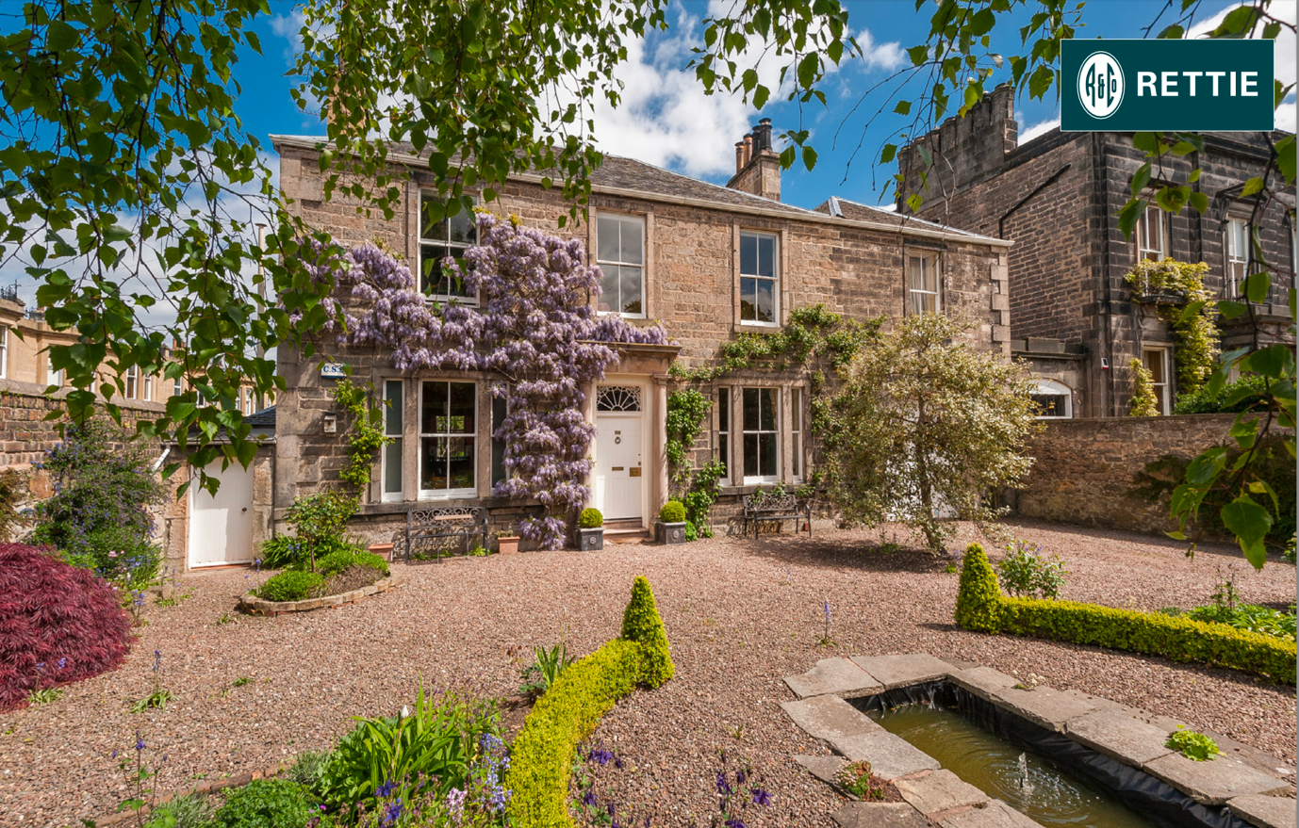

Materials Palette
The materials that have been proposed to create an improved garden have been chosen to fulfil three criteria.
1. Only make additions to the garden that enhance and tie in with the architectural integrity of the building.
2. Improve the previous additions that have been done in the garden visually so when you look at it, it feels more like a garden and less like a municipal car park attached to a beautiful historic piece of architecture.
3. Meet the family’s needs for the use of the space; they would like spaces to relax, to play, to learn about growing your own food, to entertain friends and keep their bikes in.
Some of the additions relating to the family’s needs are temporary as the family are growing up.
4. Traditionally used materials, locally sourced as much as possible and mostly organic materials showing their natural colours rather than being varnished/painted (wood, rope, sandstone, gravel)
*See Rosebank House Material Choices document for images

Tree Protection

All current garden trees are being retained, apart from a small crab apple (trunk diameter of 40mm at 1.5m above ground) which will make way for the pond.
The design states to plant a large multi-stem Pinus sylvestris ‘Watereri’ in the back garden to screen the brown brick triangular wall behind the property. This is a moderate growing tree that reaches 2.5-4m height and 4-6m width at 50 year maturity. An evergreen tree was chosen to screen the current main focal point of the garden from Rosebank House. The tree will be chosen at a moderate size already (approx. 2m high and 2m wide) and will have a wide hole dug for the root ball that will be backfilled. It will be secured into position until the roots have fully grown into the garden using a Gripple tree anchoring system to prevent any wind rock.

During construction all garden trees will be protected to BS 5837 standards. In terms of Root Protection Area the closest tree to the excavation work being done on the pond is the Silver Birch in the back garden.
Silver birch Root protection area calculation = 0.35m x 12 = 4.2m, 4.2m x 3.14 = 13.1m2
The pond excavation will be significantly smaller than this area so should not be cutting into the trees’ roots underground based on the RPA calculation. Excavation around the tree roots will be extremely limited and hand-excavated to comply with section 7.2 of BS5837.

Biodiversity

The design aims to increase biodiversity in the garden and the addition of a pond will significantly improve this (see no.12. in Design Solutions for description). The water bowl in the front may also be used as a bird bath. More ivy hedge screening will be added in the back garden which has very late flowering useful for pollinators towards the end of the summer.
There will be a significant increase in the amount and range of herbaceous plants in the garden which will increase the amount and timings of nectar production and provide more habitat for insects. The design plans to maintain the current soil structure and any excavations from the pond will go into the new flower beds in the back garden, which helps to keep the existing life on site. The front garden will keep the same gravel, this will be planted into but not dug out and replaced at all.
The design adds compost bins to recycle garden waste on site which will be a draw for many invertebrates. There will be the addition of more tree cover in the back garden. This helps in the creation of two different habitats; the front garden is a drier more Mediterranean gravel garden with veg beds and the back garden is a damper edge of woodland garden. Both will attract different insects and animals.
In terms of garden permeability, the current impermeable hardstanding in the garden counts for 19.5% of the total garden surface (109m sq out of 558m sq.). The design will reduce this very slightly to 18.8% impermeable surface with 81.2% of the surface permeable materials (105m sq. out of 558m sq.). See Hard/Soft current and proposed plan drawings for a visual comparison.

